
Christmas Order form
Turkey/Geese/Duck/Cockerel Beef
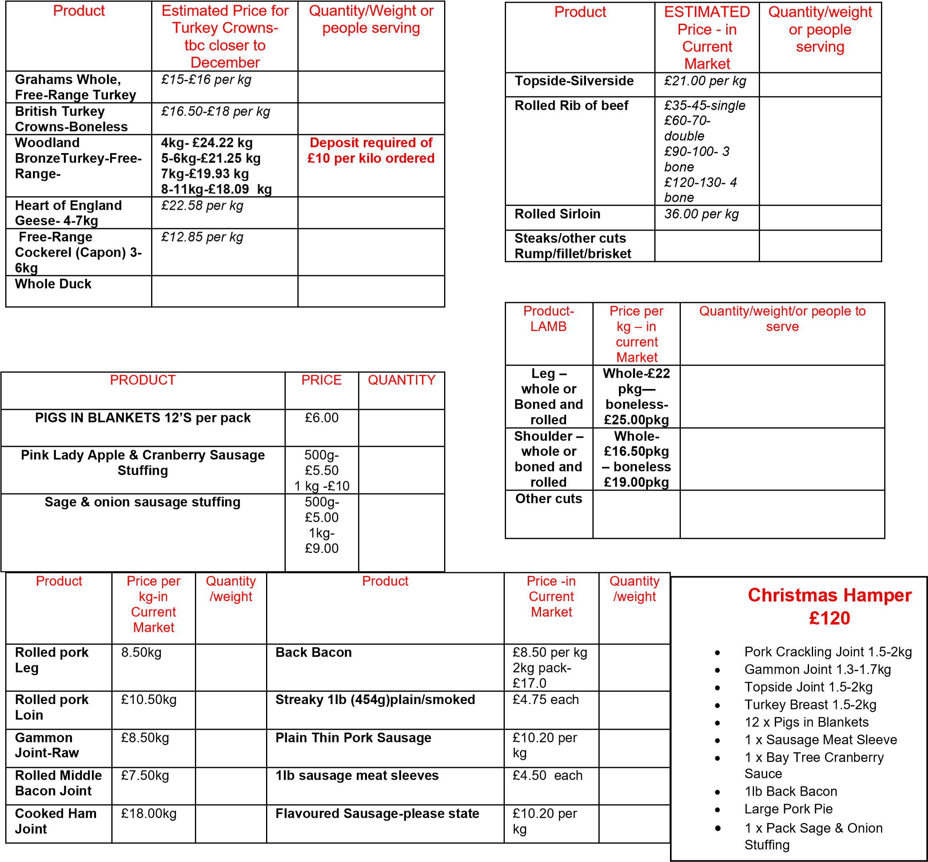
Small/Large or 2lb-Pork Pie- £2.20/£4.95/£9.50 |  | 5lb Pork Pie round tinnedestimated price- £24 |  | ASCOT/GALA-HALF OR  WHOLE  £14/£25 |  | Chicken & Ham 4lb -£25
Pork & Black pudding small/1lb  £2.20/£6 |  | Turkey Ham/ Cranberry 1b- £8.00/2lb-£16 |  | Turkey- Ham & Stuffing  1lb/2LB  £7.50/£15 |  | Pork & Stilton small/1lb/2lb  £2.40/£6.50/£15
Game pie 1lb/2lb  £8.50/£16.50 |  | Pork Caramelised onion 1lb-£7.30/2lb-£14 |  |  |  | Pork, Pickle & Red  Leicester 2lb  £9.00

